

SCHOOL OF MECHANICAL & MANUFACTURING ENGINERRING

NUST

Department of Mechanical Engineering

CS-114 – Fundamentals of Programming

LAB MANUAL #06

**Course Instructor**: Dr Khawaja Fahd Iqbal

**Lab Instructor**: Muhammad Affan

**Student Name**: Muhammad Usman Abdullah

**Section**: B

**CMS ID**: 461513

**DATE**: 14-November-2023

LAB #06 (LAB TASK)

TASK 1:

#include<iostream>

using namespace std;

int main() {

int n, a1 = 0, a2 = 1, sum = 0;

cout << "Enter the number of terms for Fibonacci Sequence: " <<endl;

cin >> n;

cout << "Fibonacci Sequence: " <<endl;

while(n>0){

for(int i = 0; i < n; ++i) {

cout << a1 << " ";

sum = a1 + a2;

a1 = a2;

a2 = sum;

}

break;

}

return 0;

}

OUTPUT:

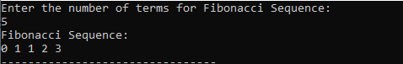

TASK 2:

#include<iostream>

using namespace std;

int main() {

int r,n=1;

cout << "Enter the number of rows for Pascal's Triangle: " <<endl;

cin >> r;

cout << "Pascal's Triangle: " <<endl;

for(int i=1;i<=r;i++){

for(int j=1;j<=i;j++){

cout<<n;

cout<<" ";

n++;

}

cout<<endl;

}

return 0;

}

OUTPUT:

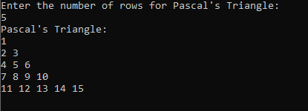

LAB #07 (HOME TASK)

TASK 1:

#include <iostream>

using namespace std;

int main() {

int sum = 0;

for (int num = 2; num <= 50; ++num) {

int i;

for (i = 2; i <= num / 2; ++i) {

if (num % i == 0) {

break;

}

}

if (i > num / 2) {

sum += num;

}

}

cout << "Sum of prime numbers from 1 to 50: " << sum << endl;

return 0;

}

OUTPUT:



TASK 2:

#include <iostream>

using namespace std;

int main(){

int a;

for(int i=1;i<=5;i++){

a=1;

for(int j=1;j<=i;j++){

cout<<a;

cout<<" ";

a++;

}

cout<<endl;

}

return 0;

}

OUTPUT:

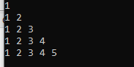

TASK 3:

#include <iostream>

using namespace std;

int main(){

int a=1;

cout<<a<<endl;

a++;

for(int i=1;i<=3;++i){

for(int j=1;j<=(i*2);++j){

cout<<a;

cout<<" ";

}

a+=2;

cout<<endl;

}

return 0;

}

OUTPUT:

